Auto Audio

Sprint 2 Plan

The Awesome Team

Sprint Completion Date: July 15, 2019

Revision 2, July 9, 2019

Goals:

1. Generate a user interface that is similar to that of real sheet music
2. Implement buttons that the user can use
   1. Start/Stop buttons

Tasks:

1. As someone who wants to learn sheet music, I want to see where the note I am playing is on the score.Wri
   1. Build basic environment for user interface. (5 story points)
   2. Display recorded notes on the environment. (8 story points)
      1. At the very least as dots on the screen.
   3. Implement note progression and memory (13 story points)
      1. Display more than one note at a time.

Team Roles:

* Erica: Product Owner, Developer
* Jeffrey: Developer
* Weixiang: Developer
* Max: Developer
* Michael: Scrum Master, Developer

Initial Task Assignment:

* Erica:
  + Make the window that implements the program
  + Create the GUI layout
* Jeffrey:
  + Write instruction manual
  + Handle additional problems that arise
* Weixiang:
  + Button functionality
* Max:
  + Find and use libraries related to sheet music
  + Link freqAnalyzer output to library input
  + Clean up freqAnalyzer output to discern between separate notes
* Michael:
  + Get library to output notes correctly given input
  + Alter output of KeyChart to fit LilyPond input

Initial Burnup Chart:

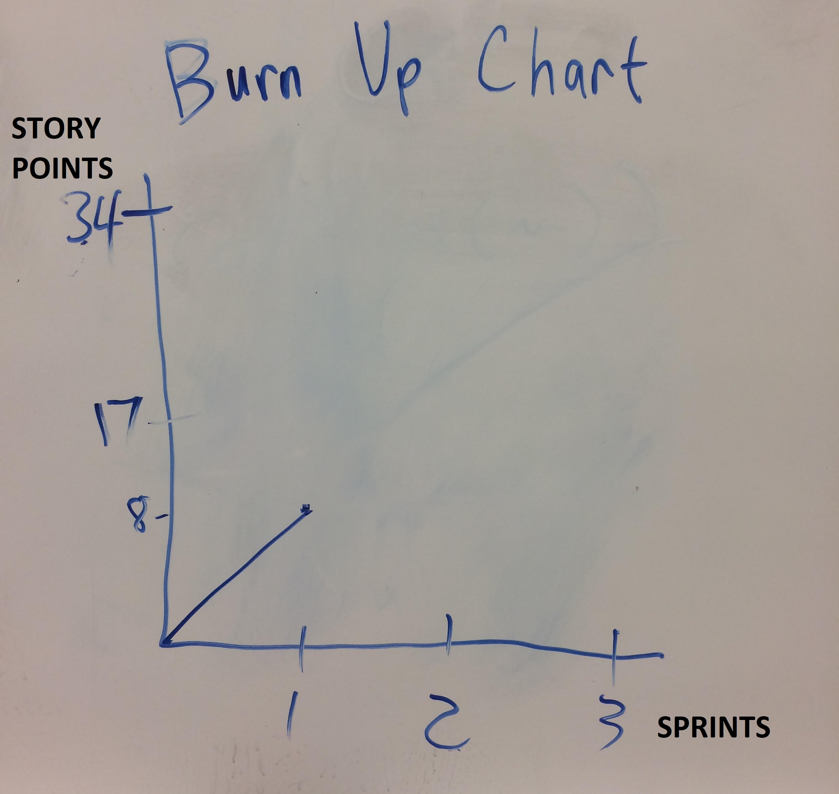

Initial Scrum Board:

|  |  |  |  |
| --- | --- | --- | --- |
| Stories: | To Do: | In Progress | Done: |
| As someone who is new to piano, I want an app that can tell me the note that corresponds to the key I am pressing so that I can learn which key is which. | Null | Null | 1. Record audio and determine its frequency. Utilizing either a software command, or hardware parts. 2. Hardcoding which frequencies are what notes. |
| As a deaf and aspiring singer, I want to be able to classify frequencies to make the learning process much more efficient | Null | Null | * Determine which note (on piano) is closest to given frequency (Algorithm) |
| As someone who wants to learn sheet music, I want to see where the note I am playing is on the score. | 1. Build basic environment for user interface. 2. Display recorded notes on the environment. 3. Implement note progression and memory | Null | Null |

Scrum times: Tuesday 2PM, Thursday 1PM (with TA), Friday 3PM